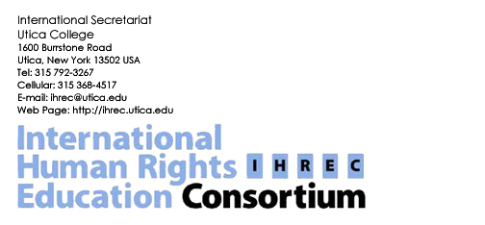
DRAFT Annual Dues- Fall 2005-Fall 2006
Form
IHREC Dues Policy- At the International Membership Meeting- Roehampton, UK (June 19, 2005) the following motion was proposed and approved and serves as the dues policy for the Consortium:

Item #14. A motion to consider membership fees for institutions, NGOs and individuals was presented to the membership. Prolonged discussion and considerations of a variety of models were discussed. It was concluded that fees be” suggested” in order to encourage participation among a broad spectrum of institutions from both the developed and developing world. Consensus was reached that members will be able to choose among “suggested amounts”.
A form will be sent to members with a membership application with boxes to check off. The suggested amounts for Universities, Colleges and Institutes of Human Rights will be (US)
$500, $350, $200, other.
The suggested amount for individuals and NGOs will be $100, $75, $50, $25, other.
Members will be able to choose the amount unless objected to (for reason) by a majority of the Executive Board.
Dues will be used primarily for support of membership activities and IHREC expenses not provided by the Secretariat.
Action: Approved with the agreement that this proposal will be reconsidered at the next IHREC international meeting (2007?).

Benefits of membership:
- The opportunity to work cooperatively with human rights education institutions world-wide
- Invitations to all Regional and IHREC meetings and events
- The member’s name(s) and addresses added to our webpage
- With permission of the member, inclusion of the membership form on the web page that includes program information
- Linking your web page to the IHREC web page
- Assistance in finding internships for the members’ students
- Assistance in providing NGOs assistance in their human rights educational work
- Assistance in finding appropriate lecturer(s) for human rights events
- The inclusion of curricula on the web page
- The inclusion of members’ information in the published IHREC Directory
- Facilitating human rights consultations among members.
- Supporting the growth and enhancement of all member’s programs and activities

Please fill in only the appropriate category
I. Universities, Colleges and Institutes of Human Rights
Name of Member University, College, Institute:
Address:

Contact person;
Email address:
Phone numbers:

Dues Amount:

(US)$ __,____ $500______ $350_____ $200____$(other)_____

II. Human Rights NGOs
Name of NGO
Address:
Contact person:
Email address:
Phone numbers:

Dues Amount:

(US)$ __,____ $100______ $75_____ $50____$25____ $(other)_____

III. Individuals
Name (with title):
Institution:
Address:
Email address:
Phone numbers:
(US)$ __,____ $100______ $75_____ $50____$25____ $(other)______
Too wire transfer funds (dues, etc.) to Utica College for the International Human Rights Education Consortium (IHREC), please contact us for routing information.

Please use the following address to mail a bank check/money order in USD to the Secretariat:
International Human Rights Education Consortium-IHREC
Secretariat
Utica College
1600 Burrstone Road
Utica, New York, 13501
USA

